Option I:
std_around_extremum.m
For a vector y(x), the standard deviation, around the maximal valued 'x':
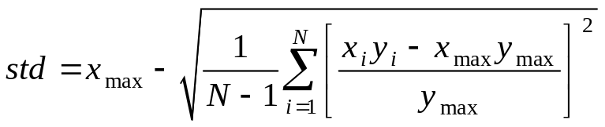

Option II:
std2_around_extremum.m
A more standard statistical definition of the second moment:
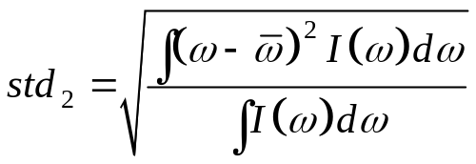

which maps into the following pseudo-code:
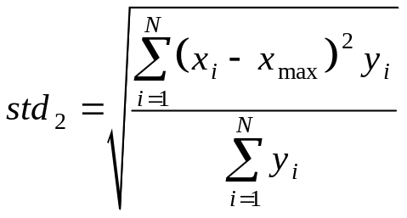

Option III:
Calculate the full width at half hight

